IC Measurement Project Document
Project:
- Voltage/Current measurements
- Functionality measurements
Connections required:
Connect SCL and SDA pins of AD3 to Sensor
IC Part No: TCS34725
Address : x29 (Please refer the below table)
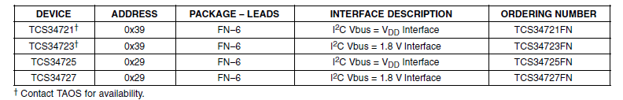
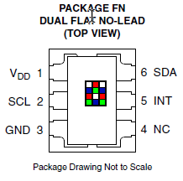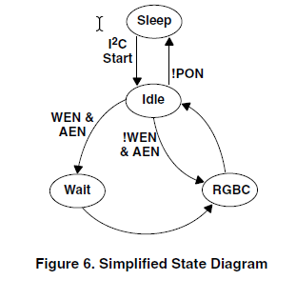
To access registers add x80 to the register address, to read what is in the clear data low address choose address as 0x94 (0x80 + 0x14)
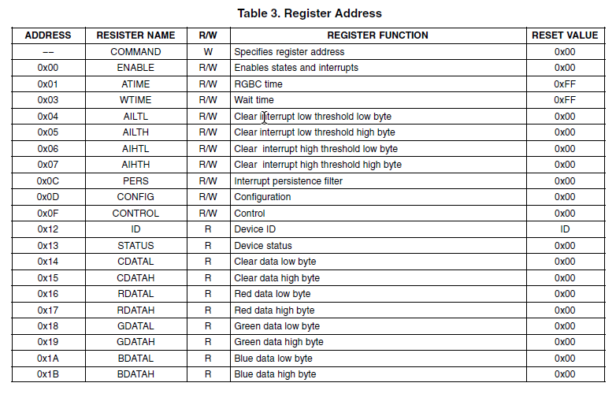
I2C State Diagram:
I2C start is enabled every time you try to access the register through I2C
Example 1: CDATAL and CDATAH (Clear Channel)
Choose address h29 in Waveforms window
Address as h94
Click on Read
Response should be h00
Example 2: AEN and WEN Command
Choose address h29 in Waveforms window
Address (Enable Register)
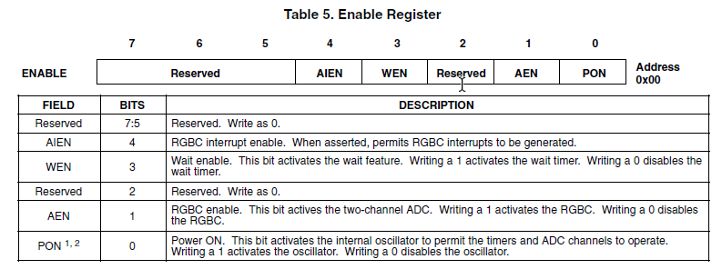
00001011 = h0B+h80 = h80
Click on Read
Response should be h00
Example 2: Device ID
Choose address h29 in Waveforms window
Address (ID Register) = h92 (h80 + h12)
Click on Read
Response should be h4D
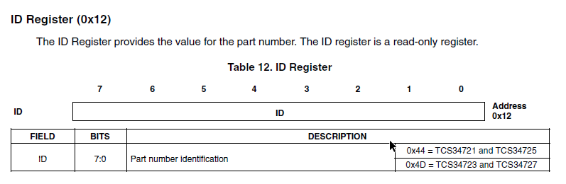
Example 2: Read Blue Channel (Change the address value for different channels)
Choose address h29 in Waveforms window
Address (ID Register) = h9A (h80 + h1A) (BDATAL)
Address (ID Register) = h9B (h80 + h1A) (BDATAH)
Click on Read
Response should be h4
Notes: I2C
S A R/W E
Write: SAWE
AW – 8 bits or 1 byte
Read: SARE
RGBC Operation
- RGBC gain control (AGAIN)
- RGBC Integration time (ATIME)
For example, if a 100-ms integration time is needed, the device needs to be programmed to:
256 − (100 / 2.4) = 256 − 42 = 214 = 0xD6
Conversely, the programmed value of 0xC0 would correspond to:
(256 − 0xC0) × 2.4 = 64 × 2.4 = 154 ms.
Control Register for Gain Control (0x0F)
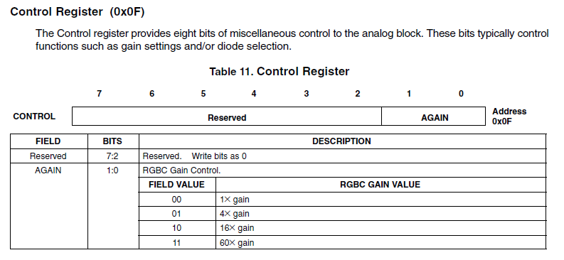
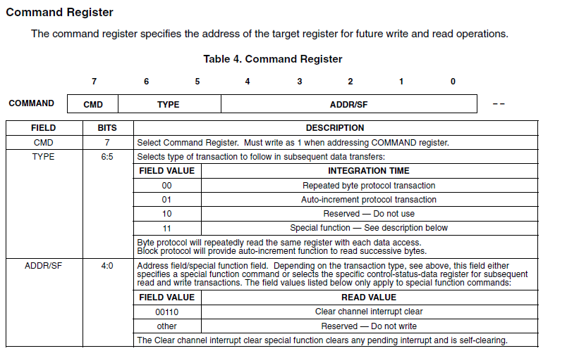

Steps to connect the sensor
- Connect the correct AD3 device
  - Enumerate and getting no of devices available (FDwfEnum)
  - hdwf = C_int()
  - c_int(-1) choose the first device
- Power ON the AD3 (refer AnalogI).py) or dwf constants
- Questions: Check the Gain, Check the ATIME
dwf. FDwfAnalogIOReset(hdwf)
dwf. FDwfAnalogI0Channe1NodeSet(hdwf, c_int(®), c_int(1), _double(5.0)) dwf. FDwfAnalogIOChannelNodeSet(hdwf, c_int(e), c_int(0), c_double(1)) dwf. FDwfAnalogI0ChannelNodeSet(hdwf, c_int(1), c_int(1), c_double(-5.0)) dwf. FDwfAnalogI0ChannelNodeSet(hdwf, c_int(1), c_int(0), c_double (1))
dwf. FDwfAnalogI0EnableSet(hdwf, c_int(1))
time. sleep(0.5)
vpos = _double()
vneg = _double()
dwf. FDwfAnalogI0Status(hdwf)
dwf. FDwfAnalogI0ChannelNodeStatus(hdwf, c_int(8), c_int(1), byref(vpos)) dwf. FDwfAnalogI0ChannelNodeStatus(hdwf, c_int(1), c_int(1), byref (vneg))
print(f"Power: +(vpos. value:.2f}V, {vneg.value: .2f)V")

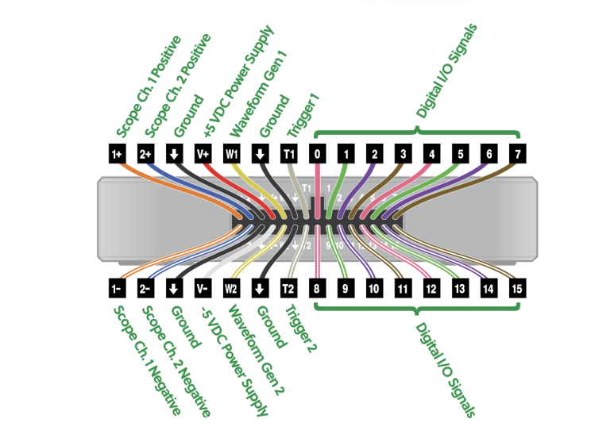
def write_register(reg, value) :
iNak = c_int()
rgTX = (c_ubyte * 2) (reg, value)
dwf. FDwfDigitalI2cWrite(hdwf, c_int(DEVICE_ADDR), rgTX, c_int(2), byref (iNak))
return iNak.value == 0
def read_register (reg):
iNak = c_int()
rgTX = (c_ubyte * 1) (reg)
dwf. FDwfDigitalI2cWrite(hdwf, c_int(DEVICE_ADDR), rgTX, c_int(1), byref (iNak))
if iNak. value == 0:
rgRX = (c_ubyte * 1) ()
dwf. FDwfDigitalI2cRead(hdwf, c_int(DEVICE_ADDR), rgRX, c_int(1), byref (iNak))
if iNak.value == 0:
return rgRx[0]
return None
dwf. FDwfDigital12cRateSet(hdwf, _double(108e3))
dwf. FDwfDigital12cSc1Set(hdwf, c_int(0)) dwf.FDwfDigitalI2cSdaSet(hdwf, c_int(1))
iNak = c_int()

